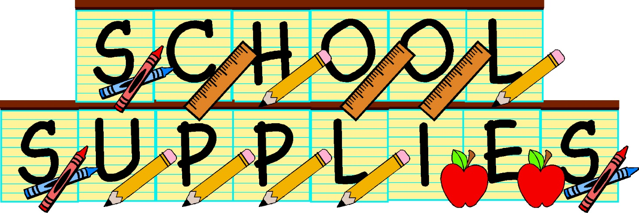  
Clear or Mesh Book bag

Glue Sticks (no liquid glue)

Crayons (to keep at home for homework)

Pencils

The following items will be provided   
for your child in the classroom:

Daily Folder

Pencil Box

Crayons

Scissors

Pencils

Erasers  
Glue Sticks